ACTIVITY N°1
Write HOW MUCH or HOW MANY. (escribe how much o how many dependiendo si es contable o incontable) (ayúdate de las guías anteriores)

2. Write FEW, A LITTLE, A LOT according to the sentence. (escribe few, a little, a lot dependiendo de la oración)

Remember:
A LOT OF: (mucho) A LITTLE: (un poco) A FEW: (ALGUNAS/ALGUNOS)

- There are _________________ candles in the cake .

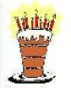 2. There are _________________ candles I the cake.

- There is ______________ of coffee on the pot. 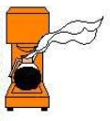

- 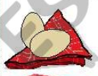There are ______________ eggs in the fridge.

- There are _____________________ soda bottles. 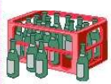

READ AND PRACTICE THE FOLLOWING. (lee y practica lo siguiente)

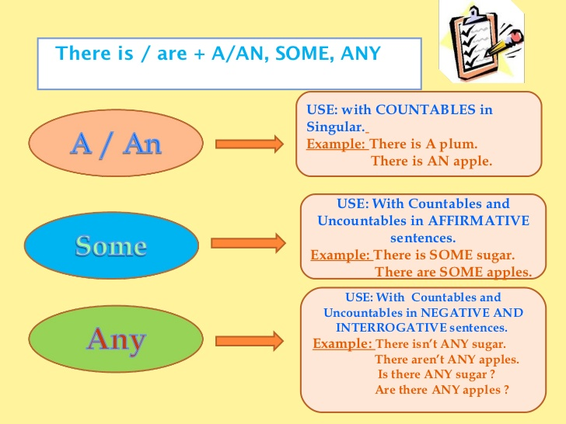
ALGUNOS
ALGUNOS
UN/ UNA
A >> si la siguiente letra es consonante
AN >> si la siguiente letra es vocal

Complete the following using a, an, some, any. (completa usando a, an, some, any)
