WORKHEET Nº2 UNIT STARTER
SUBJECT : ENGLISH
UNIT: STARTER
GRADE: 8TH
NAME:…………………………………………………………………………………DATE:……………………………………………………………………
GRADE: ……………………
Instructions: Do the vocabulary, grammar, reading and writing exercises. Use your knowledge, dictionary and your notebook.
- Vocabulary : Read the sentences to complete the crossword puzzle: Lea las oraciones para completar el crucigrama. En negrita estan las palabras clave.
Jobs Crossword:
Down
2. A person who helps a doctor.
4. Someone who delivers mail.
5. Somebody who helps sick animals.
6. Somebody who puts out fires.
9. Someone who digs for metal ore in the ground.
10. Someone who cooks food.
11. A person who paints pictures.
12. A person who protects a country.
14. Someone who cleans buildings.
15. A person who makes computer games.
16. A person who goes to outer space.
18. A person who tells us the news.

Across
1. Somebody who plays
an instrument.
3. Someone who grows crops.
7. Somebody who fixes teeth.
8. A person who serves food.
9. Someone who fixes cars.
13. Somebody who catches criminals.
16. A person who plays sports.
17. Someone who stars in a movie.
19. A person who sings songs.
20. Somebody who helps sick people.
21. Somebody who flies airplanes.
22. A person who does experiments.
23. Somebody who teaches.

VOCABULARY
SOMEBODY/ SOMEONE: ALGUIEN/UNA PERSONA
WHO: QUE/ QUIEN/ A QUIEN
DOES: HACER/ CREAR

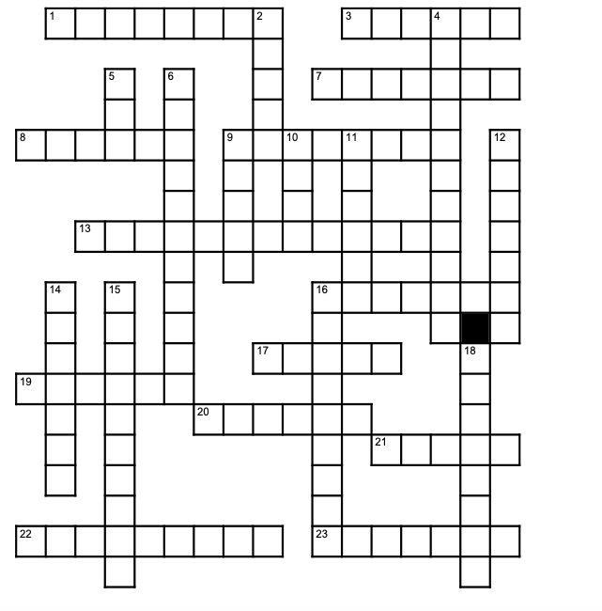

- Write related words according to the following words: escriba palabras relacionadas a cada profesión.

TEACHER | DOCTOR | SECRETARY | POLICEMAN | CHEF
Ex: teachs/enseña
- Write the names according to the numbers. Escriba los nombres de acuerdo a los números.

- _________ lives at number forty six. 4._________ lives at number seventy eight.
- _________ lives at number eighty one. 5. _________ lives at number fifty seven.
- _________ lives at number ninety nine. 6. _________ lives at number twenty four.

- Select the correct ORDINAL NUMBER. seleccione el número ordinal correcto.

- Twelfth  - Second  - Twentieth | - First  - Fifteenth  - Fifth | - Ninetieth  - Ninth  - Nineteenth
- Fifth  - First  - One | - Eighteenth  - Eighty  - Eighth | - Twenty two  - Twenty – second  - Twentieth two

- Reading:Read the sentences and complete with the words from the box:
Lea las oraciones y complete con las palabras del cuadro.
tennis - climbing - diving - baseball - caving
F

1. In this sport, you use a rope and special equipment for climbing rock faces.__________________________________
2. Explore caves as a sport.__________________________________________
3. A ball game played chiefly in the US between two teams of nine on a diamond- shaped circuit of four bases. _________________________________
4. Plunge head first into water with one's arms raised over one's head. _____________________
5. A game in which two players strike a hollow rubber ball with rackets over a net stretched across a grass court. ___________________________________
VI. Unscramble the following words: Escriba en forma correcta las palabras.
1) BKSATEBLLA : ________________________________
2) JGGONGI: ___________________________________
3) VLLOYEBLLA: _________________________________
4) TNNIES: _____________________________________
5) KTARAE: _____________________________________
6) CIYCLNG: ____________________________________
7) GMYASNTCIS:_________________________________
VII. Writing : Write am, is or are: Escriba am/ is /are:
Hi!
I ..................... Peter and this .......................... Emma. She ........................ my sister. We .................... brother and sister. I ................... eleven and she .......................... ten. We ................... from Salford. Salford ......................... near Manchester. What ............................ your name? Where ........................ you from?

- Grammar : Write sentences. Escriba oraciones .Use the correct form of be. Use la forma correcta del verbo to be. IS/AM/ARE.
Example / ejemplo
- I/young I AM YOUNG
- She / clever _________________________________________________
- You / not old _________________________________________________
- You/sleepy
_________________________________________________
- We / not naughty _________________________________________________
- She / not short _________________________________________________
- It/rainy
_________________________________________________
- They / unhappy
________________________________________________
- He / not hungry ________________________________________________

j. They / tidy _________________________________________________

k. He / handsome ____________________________________________

