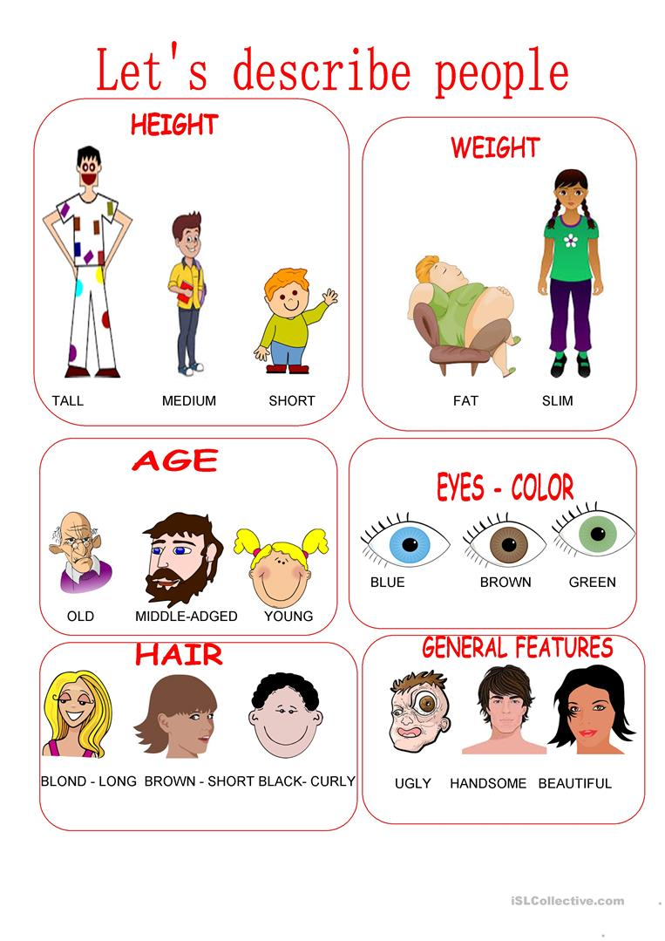
- TALL: ALTO 9. BLUE EYES: OJOS AZULES 17. CURLY HAIR: PELO RIZADO
- MEDIUM: MEDIANO 10. BROWN EYES: OJOS CAFES 18. STRAY HAIR: PELO LISO
- SHORT: BAJO 11. GREEN EYES: OJOS VERDES 19. UGLY: FEO
- FAT: GORDO 12. BLOND HAIR: PELO RUBIO 20. HANDSOME: GUAPO
- SLIM: DELGADO 13. BROWN HAIR: PELO CAFÉ 21. BEAUTIFULL: BELLA
- OLD: VIEJO 14. BLACK HAIR: PELO NEGRO
- MIDDLE-AGED: ADULTO 15. LONG HAIR: PELO LARGO
- YOUNG: JOVEN 16. SHORT HAIR: PELO CORTO

Activity 1
Match the picture with the description. (une la imagen con la descripción)
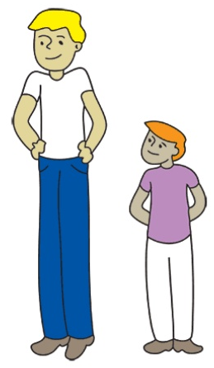
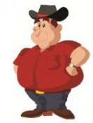
LONG HAIR

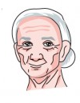
SHORT
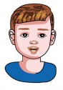
CURLY HAIR
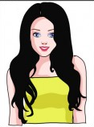
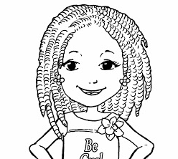
FAT

SHORT HAIR
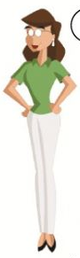
SLIM
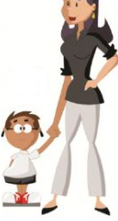
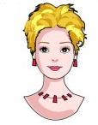
TALL

OLD
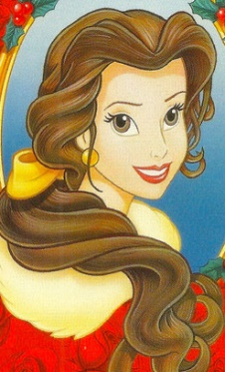
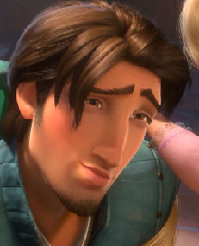
BEAUTIFULL

YOUNG

HANDSOME

2. DESCRIBE 3 MEMBERS OF YOUR FAMILLY OR FRINDS. (describe 3 miembros de tu familia o amigos)
EXAMPLE:
MY SISTER IS TALL AND SLIM
SHE HAS BLOND HAIR AND BLUE EYES
SHE IS YOUNG AND BEAUTIFULL
NAME: __________________________

SHE >> ELLA
HE >> EL
HAS >> TIENE

NAME: ______________________________

NAME: _____________________________

3. DESCRIBE 4 ASPECTS OF EACH. (describe 4 aspectos de las siguientes personas)

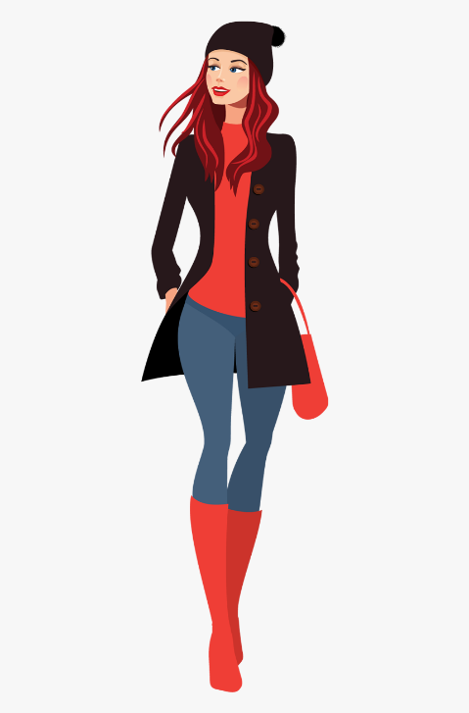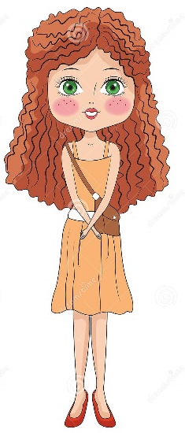

_______________________ _______________________ ______________________

_______________________ _______________________ ______________________

_______________________ _______________________ ______________________
ADVISE/ CONSEJO
PRACTICE AND REPEAT ALL THE VOCABULARY LERNED IN EVERY WORKSHEET.

PRACTICA Y REPITE TODO EL VOCABULARIO APRENDIDO EN ESTAS GUIAS.
REMEMBER THIS:
SHE >> ELLA
HE >> EL
IS >> ES
HAS >> TIENE

